**ZERTO TEST DR PLANNING AND EXECUTION**

**FOR WSP**



Atos for internal use

author(s) : Anand Nevrekar

version : 1.0

status : Draft

source : Atos

document date : 12th April 2019­

­

­

**SUMMARY:**

The purpose of this document is to understand how WSP Zerto DR Test activity is carried out from protected site to recovery site. This exercise is performed in the isolated DR environment with NO impact to production.

Zerto appliance is hosted in UK region where TEST DR is planned once in 6 month and Production DR is scheduled once in a year. So, from VCenter point of view, the protected site (Primary Datacenter) in UK region is “Dcema100vca01.corp.pbwan.net” which has production servers hosted and recovery site is set to “gblon500vca01.corp.pbwan.net” but for some vms, it is vice-versa. It is asynchronous replication form Protected site to Recovery site.

Zerto Appliance is available in both protected site and recovery site. To connect to Zerto Appliance, you can either connect to url <https://10.44.100.143:9669> from protected site or access recovery site url <https://10.44.100.153:9669>. However, to perform DR activity, Zerto appliance from **recovery site has to be connected. For UK region, recovery site url is “**[**https://10.44.100.153:9669**](https://10.44.100.153:9669)**”.**

In Zerto Appliance, there are multiple VPG groups created which is called Virtual Protected Groups. The naming standard for VPG group is based on application name which is provided by customer. Therefore, target vms representing the application are added into the respective VPG Group.

**Following are the steps for Test DR execution:**

1. Please connect to Zerto Recovery (DR) Site to perform DR. In this case recovery site url is <https://10.44.100.153:9669>. Once you logon to this URL with user id “xxDASIDit5”, the following Dashboard will be displayed. If you notice VPG HEALTH status, it shows 90% in orange which indicates warning of DR.

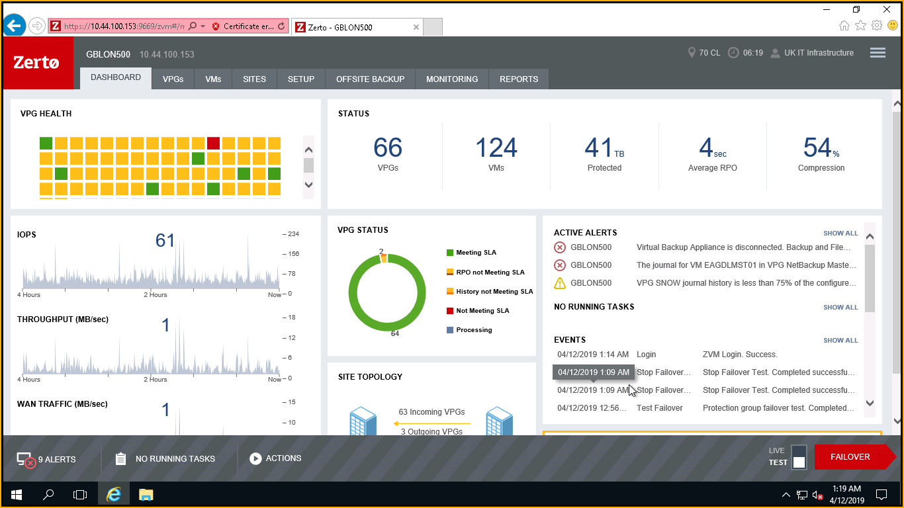

1. Click on VPGs group tab and search for target group name “CORP SQL HOTEL” which will show up the name.

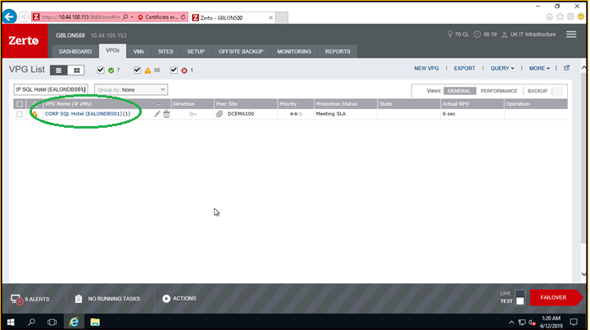

1. The VM names from the VPG group can be explored from VMs tab. The VPG group “CORP SQL Hotel” has only single vm. Select VMs tab and type VPG group name. From the following snap, the arrow highlighted in green under Direction pane is pointing to right side from Peer site DCEMA100. This explains that replication is directed from primary site DCEMA100.

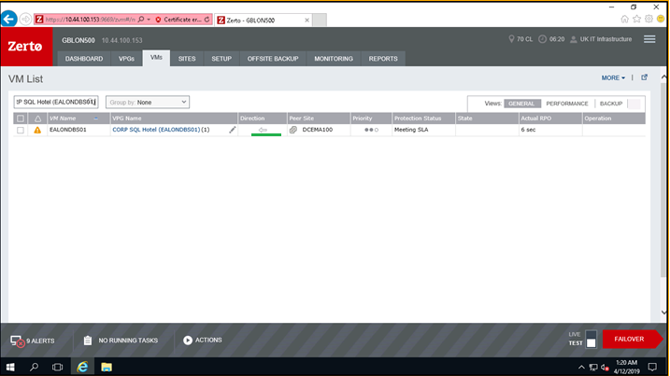

1. We go back to VPGs tab and click on VPG group name which will open up in new window pane as shown below.

The ACTIVE ALERTS option circled shows warning message that DR drill has not taken place for last 6 months.

Now click on EDIT VPG tab and the result shown in point 5.

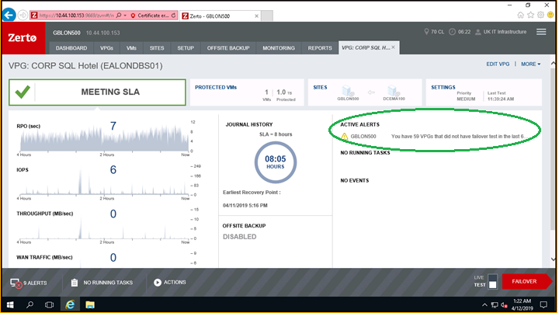

1. From the following snap, select NICs tab and against VM Name it shows network group “dv_100_server” and Test Netowork group as “dv-701_Test_Isolated”. So, during SOFT/TEST DR failover, the target vms will be online/mounted to TEST DR site which is isolated network group of 701 vlan which will not affect production environment.

**Note: If it was actual failover then it would have mounted target vms to failover to production network “dv_p100_Server”.**

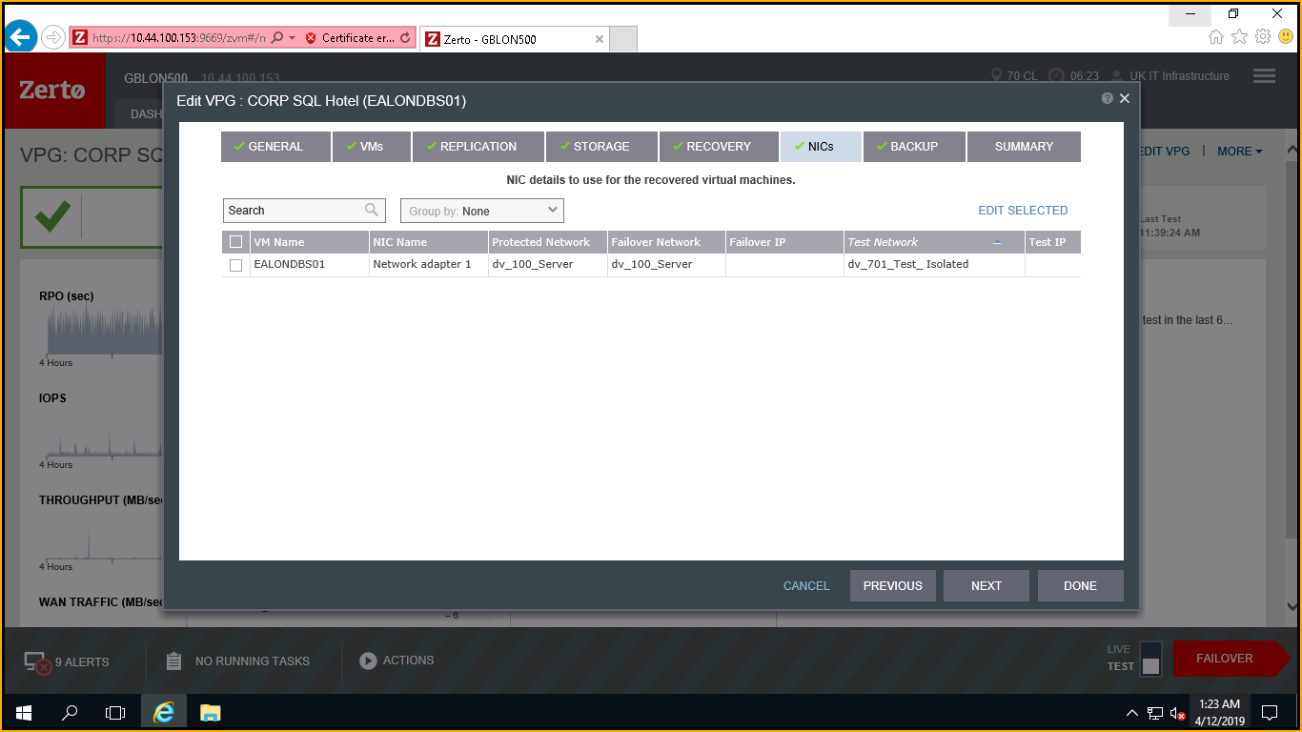

1. Back to the VPGs tab, checkbox the VPG group name and from right corner at bottom, click on TEST FAILOVER option. The TEST is by default selected.

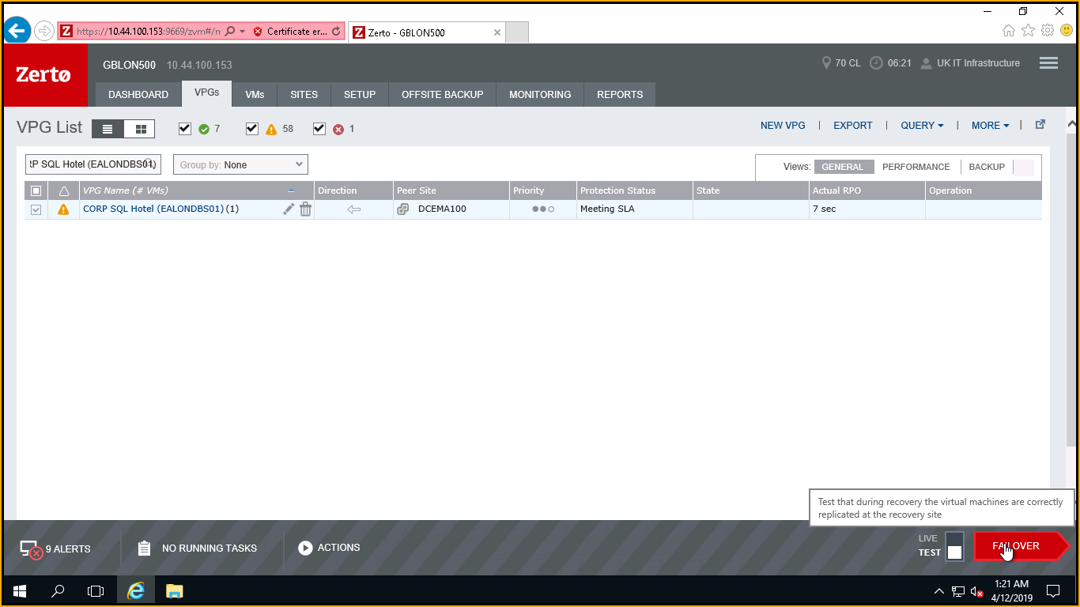

1. Click on the Next button shown in the following snaps.

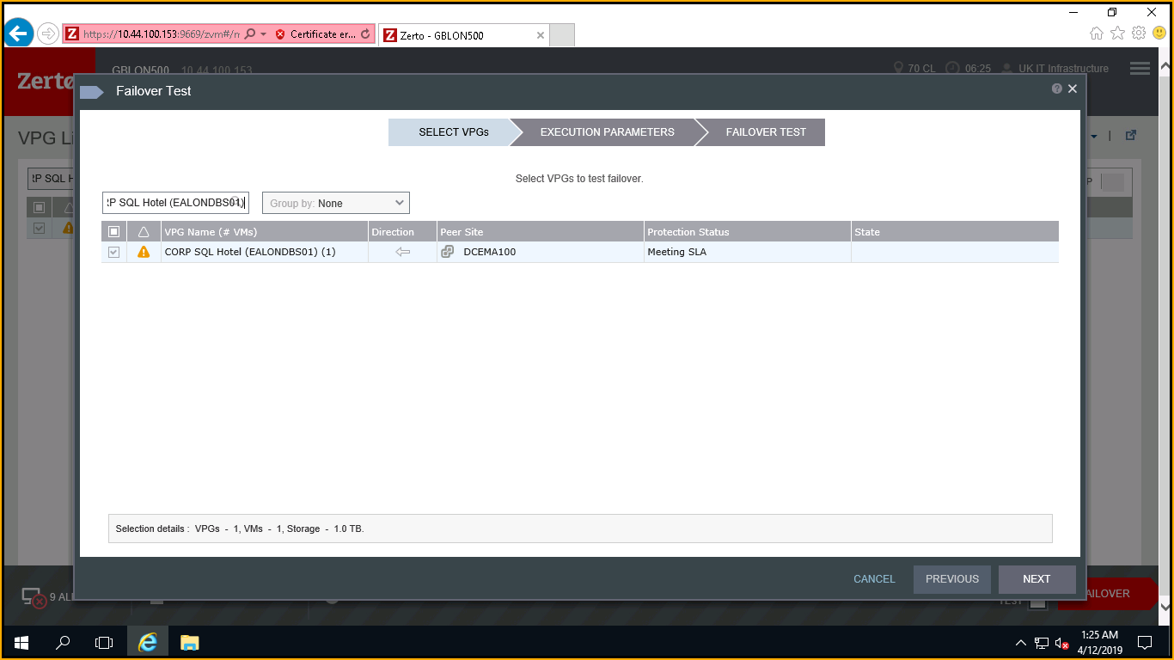

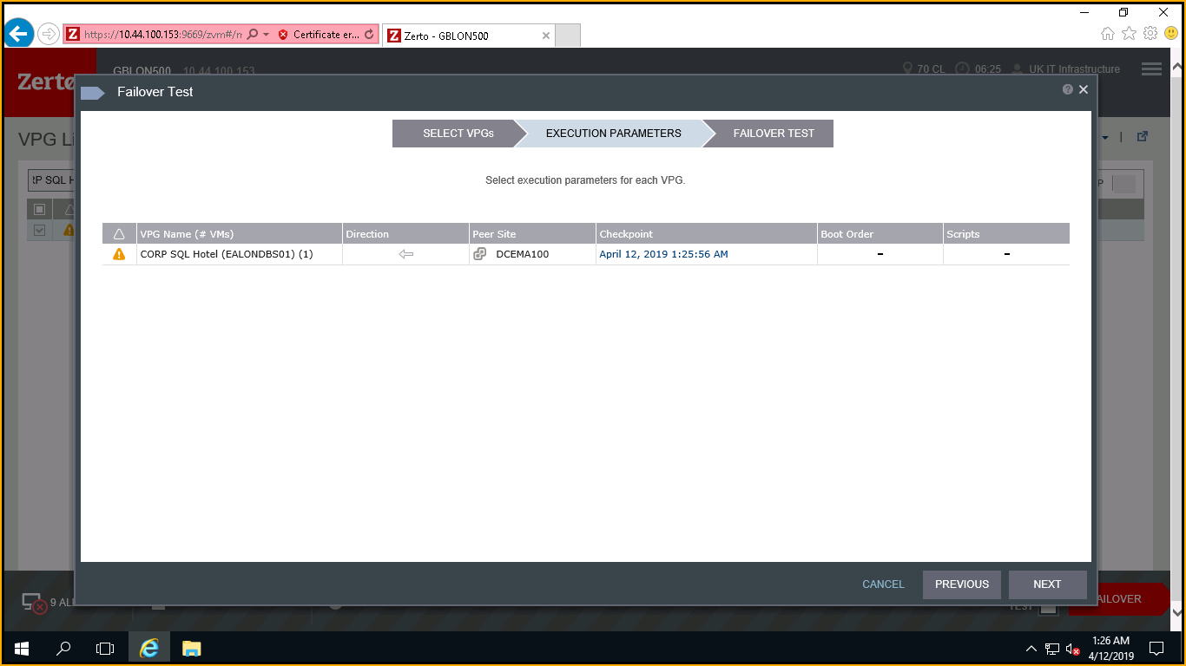

1. Please refer the highlighted Ready to Failover Test status clearly shows with arrow sign that DR flow is progressing from protected/primary site DCEMA100 to recovery site GBLON500. Click on START FAILOVER TEST.

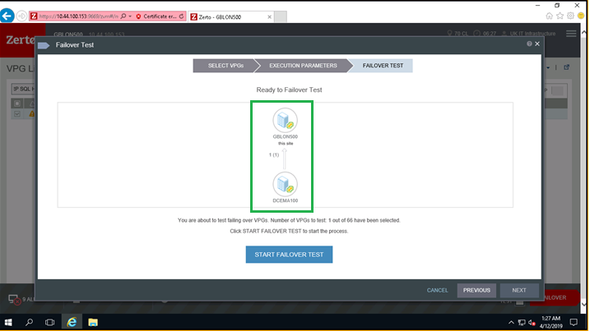

1. RUNNING TASKS on the status bar would show Failover Test status which is indicating 43% in progress.

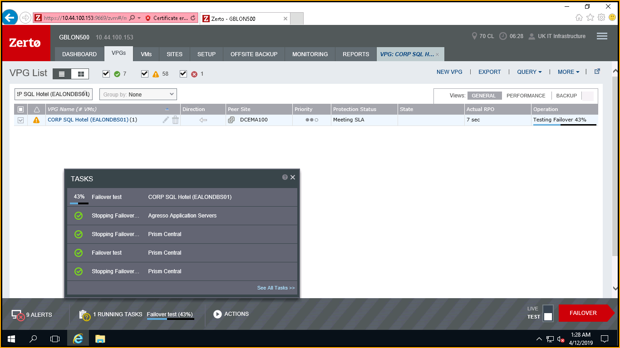

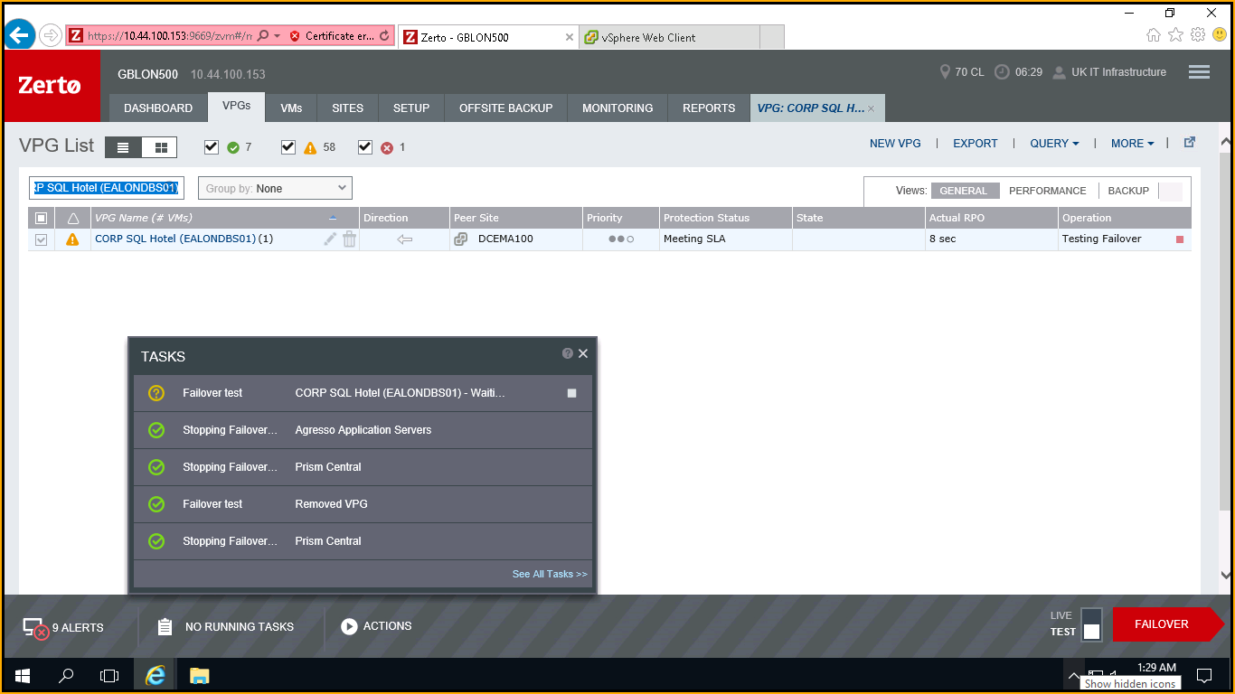

1. Once Failover Test task is complete, you can check target VM status from VCenter under recent task.

Look for target vm by typing the name of vm in search pane shown to right side on the top.

You would find master VM name “EALONDBS01” which is in production and newly created VM name in DR titled “EALONDBS01 – testing recovery”. Post check would be conducted on DR vm EALONDBS01 – testing recovery.

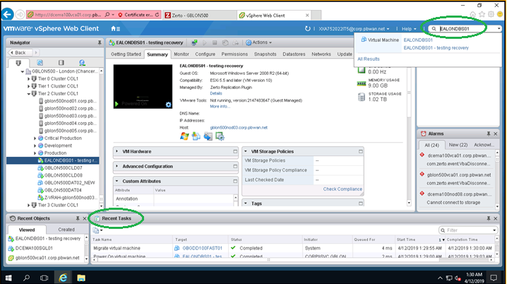

1. The VM “EALONDBS01 – testing recovery” is now online and all resources are available as shown in the following snapshot.

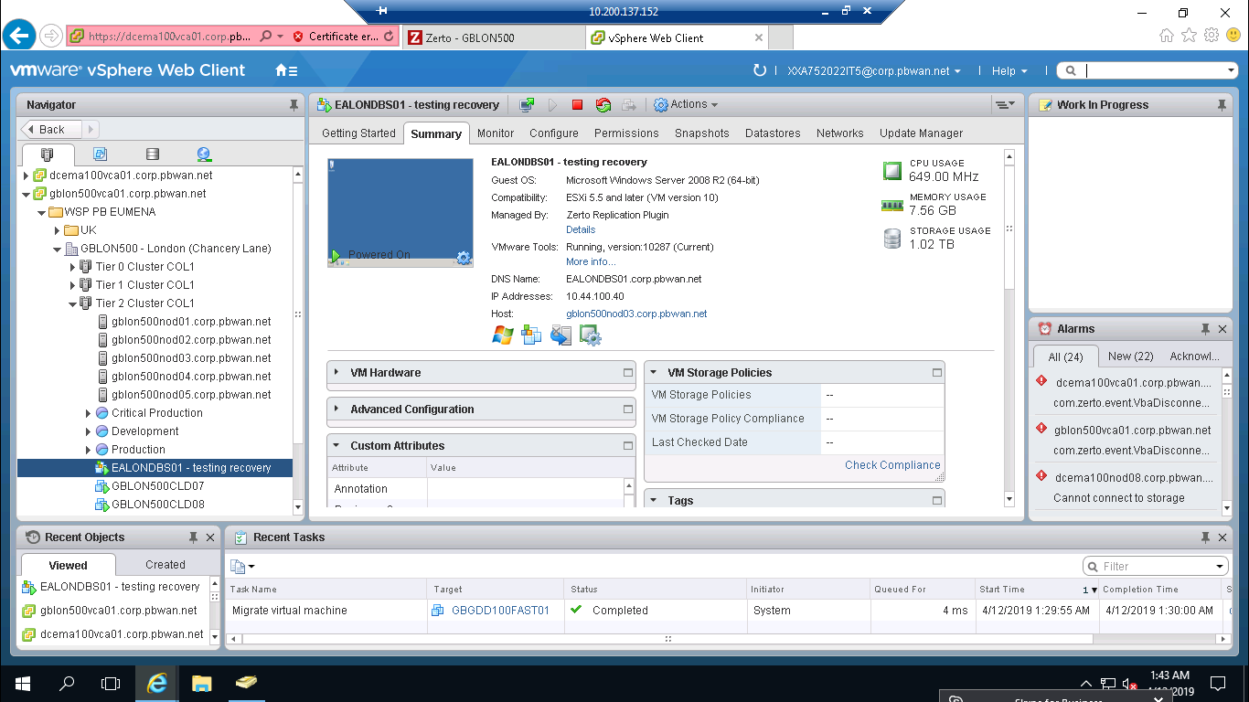

1. There is chance of VM not getting up/online with the message popping up as mac address conflict.

In such case, right-click on the vm and select Edit Settings...

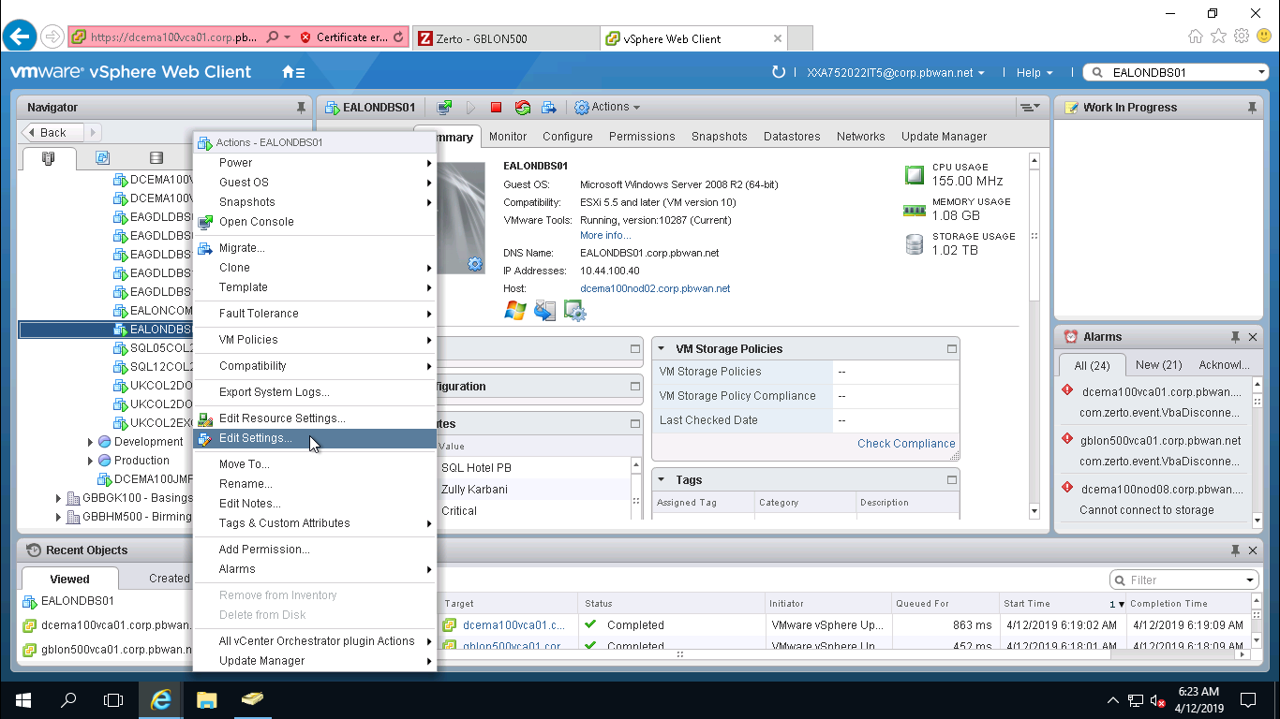

1. Cascade **Network Adapter 1** by clicking on arrow and from MAC Address, click drop down selection and change Manual to Automatic and click OK button to complete action.

**Note: Since VM in the following snapshot is online and therefore, MAC Address option is greyed out. You need to opt to set MAC address of VM to automatic in case the VM is not getting powered on gracefully after Failover Test execution is completed.**

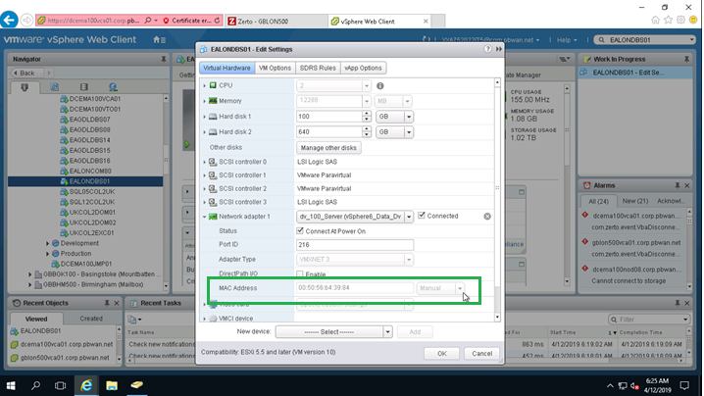

1. Once target VM “EALONDBS01 – testing recovery” is up, then all application owners need to verify functionality of the application in DR site. Once confirmation of successful running of application is received, then we can stop the Testing Failover operation. Please follow the process as per the snapshot given below to stop failover test.

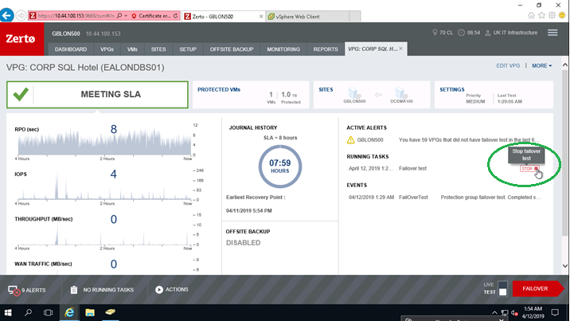

Click on STOP button.

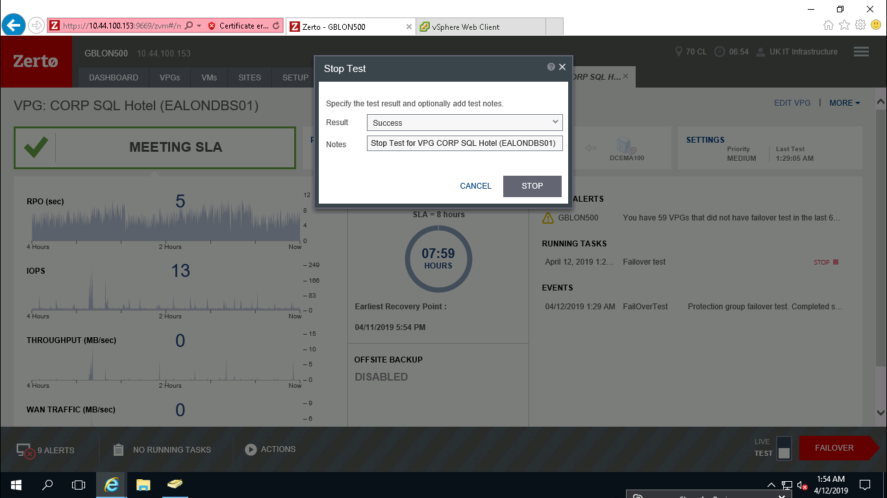

1. Once Failover Test is triggered, it will show progress status.

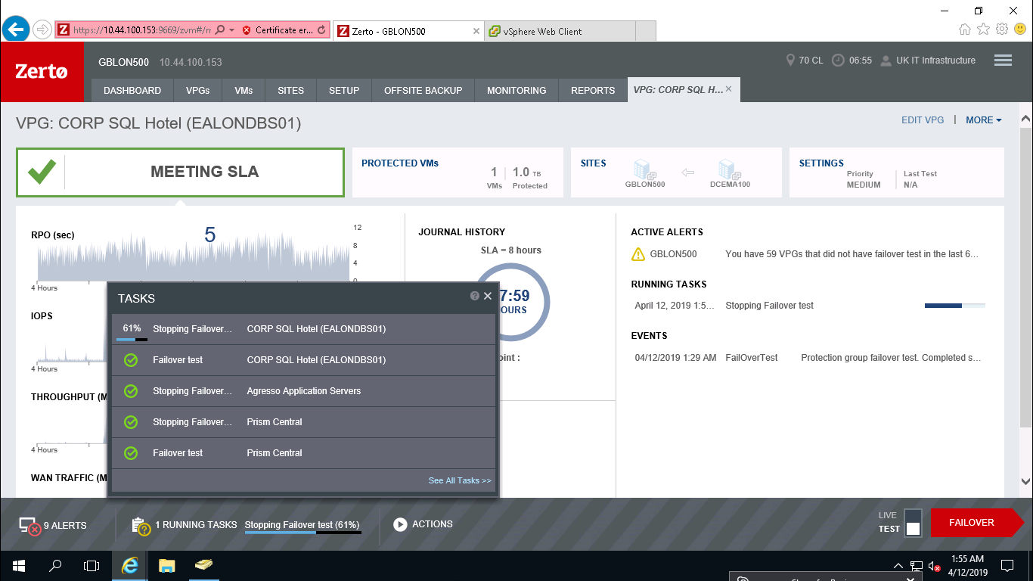

From VCenter under Recent Task, you can view triggered action for vm simultaneously.

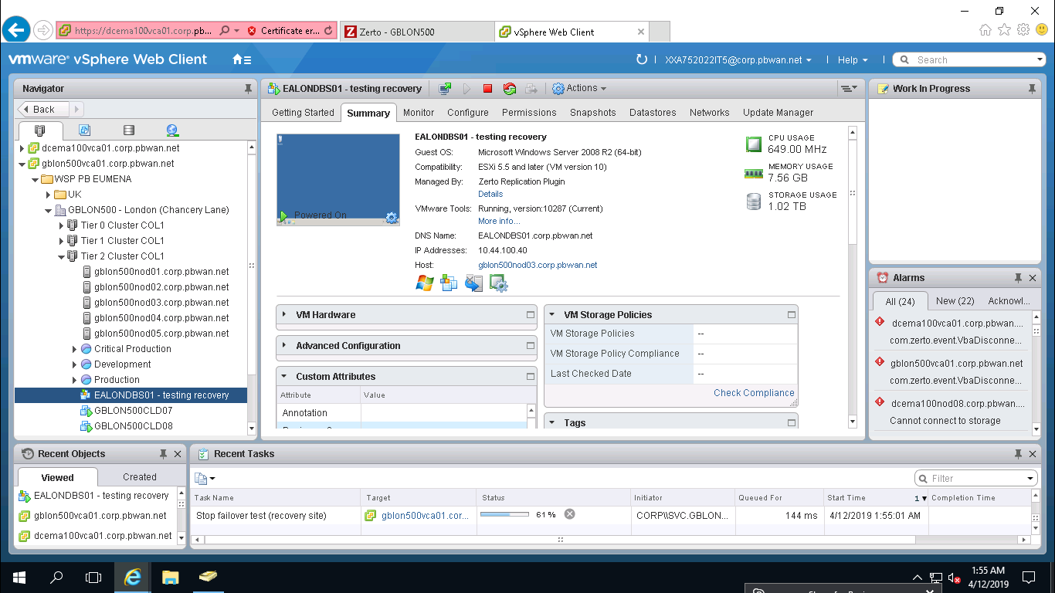

1. Stopping Failover Test has completed successfully and you would see now the VPG group status showing as **MEETING SLA** and warning alerts have cleared.

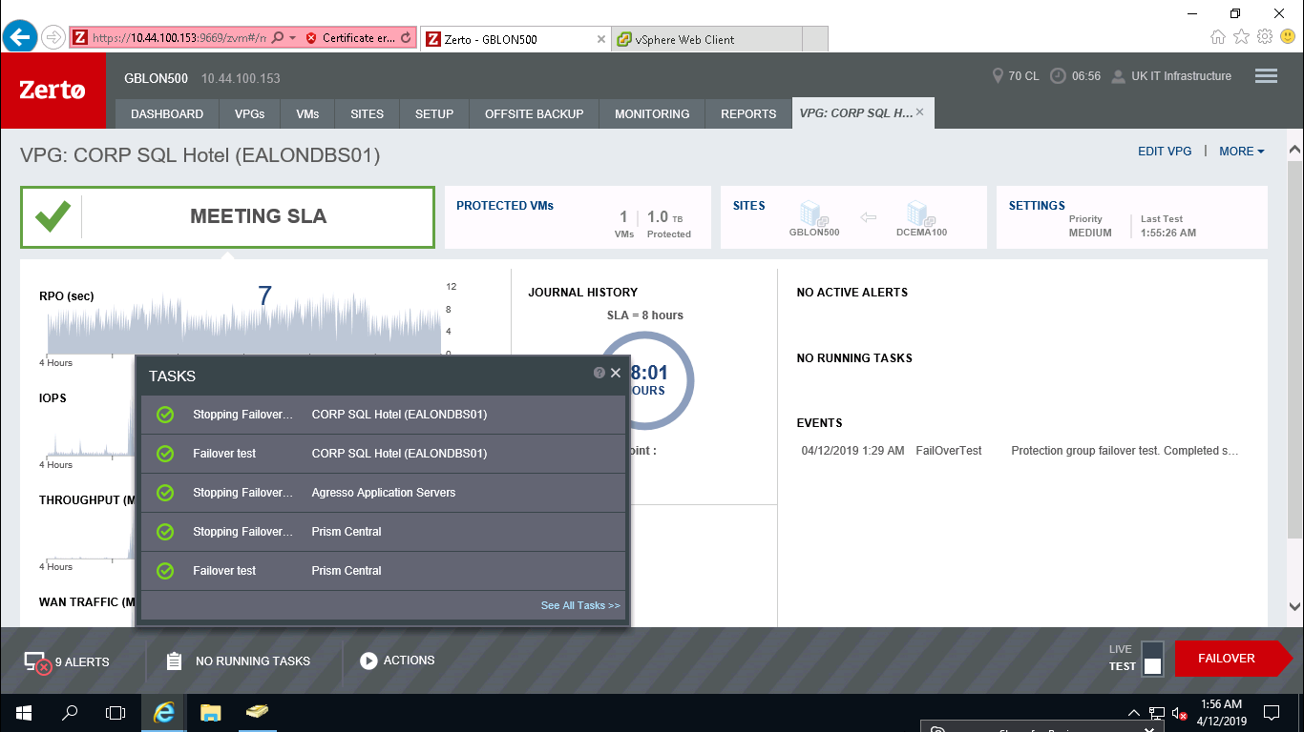

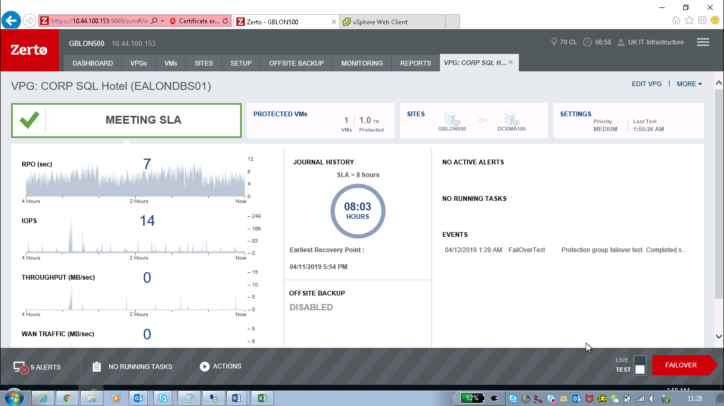

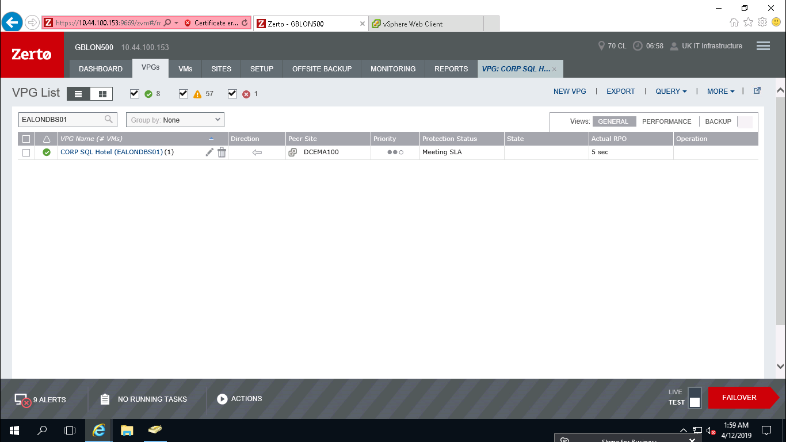

1. From VCenter console also, the action is completed and DR virtual machine “EALONDBS01 – testing recovery” has been automatically removed from VC. With this, Zerto DR activity for VPG group “CORP SQL HOTEL’ is completed.

